**3.1.8- 3.1.9 Entry Ticket**

|  |  |  |
| --- | --- | --- |
| **3.1.8.c** | **recognise** that indicators change colour when the pH = pKa and **identify** an appropriate indicator for a titration, given equivalence point of the titration and pH range of the indicator. |  |
| **3.1.9.a** | **distinguish** between the terms end point and equivalence point |  |
| **3.1.9.c** | **sketch** the general shapes of graphs of pH against volume (titration curves) involving strong and weak acids and bases. **Identify** and **explain** their important features, including the intercept with pH axis, equivalence point, buffer region and points where pKa = pH or pKb = Poh  NOTE: Titration of weak acid to weak base is not required. |  |
| **3.1.9.d** | **use** appropriate mathematical representations and **analyse** experimental data and titration curves to **solve** problems and make predictions, including using the mole concept to calculate moles, mass, volume and concentration from volumetric analysis data. |  |

**QUESTION 1:**

Identify which of the following indicators could be used to detect the end point when a strong base is titrated

with a weak acid.

(A) methyl red

(B) methyl orange

(C) phenolphthalein

(D) bromothymol blue

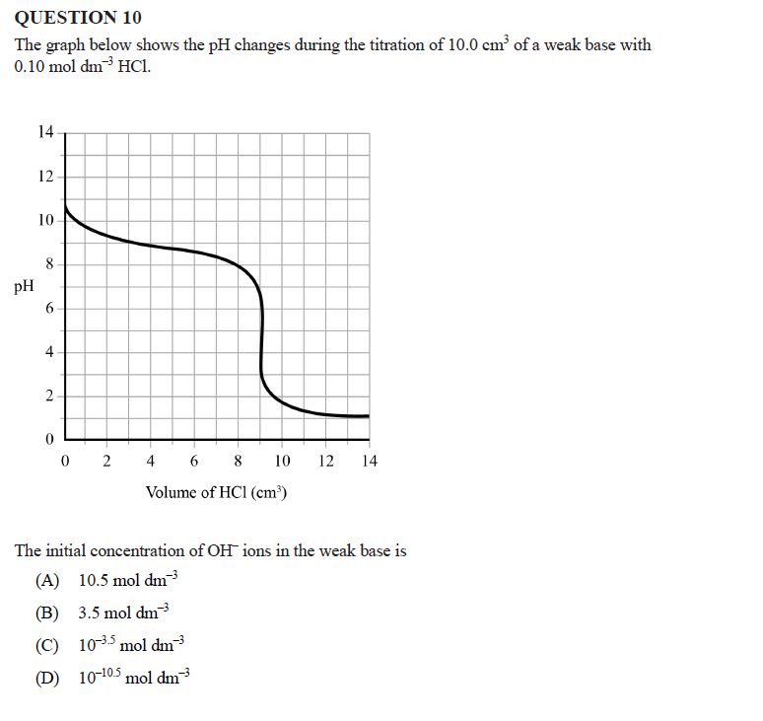

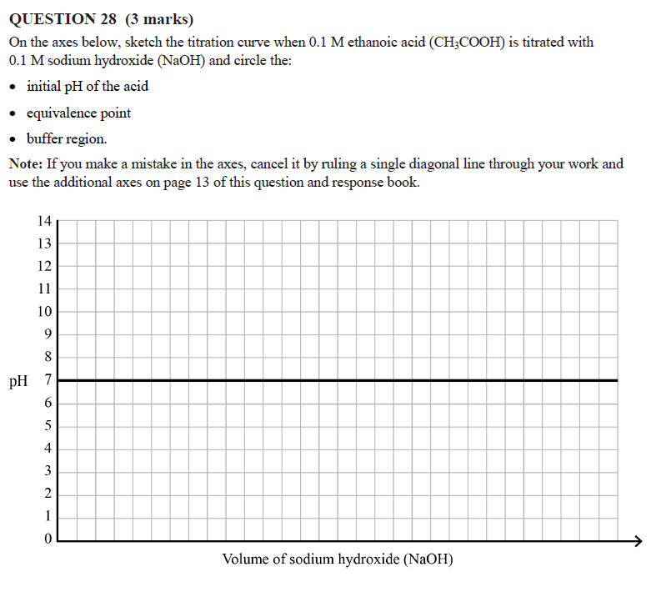

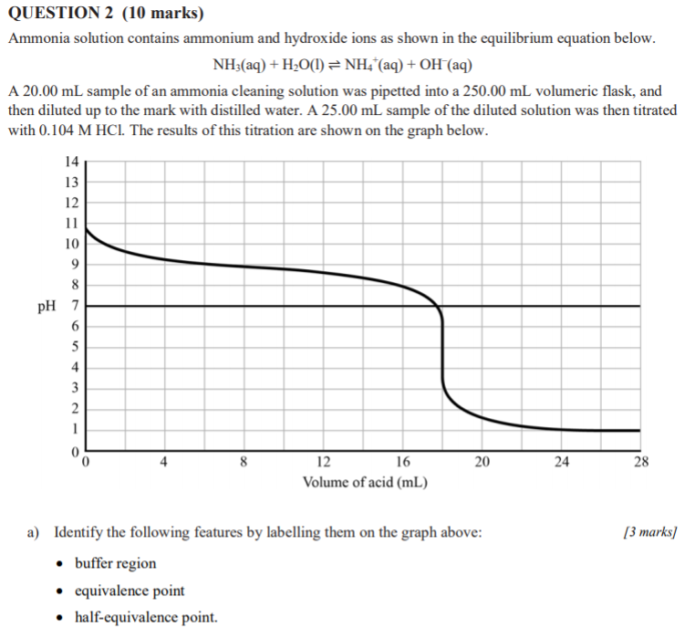

1. **Distinguish** the half equivalence point from the equivalence point in terms of pH and volume of HCl. [2 marks]

|  |
| --- |
|  |
|  |
|  |
|  |

1. **Calculate** the concentration in mol L -1 of ammonia (NH3) in the cleaning solution. Show your working. [3 marks]

|  |
| --- |
|  |
|  |
|  |
|  |
|  |
|  |